Bitcoin Value Prediction Using Machine Learning
Submitted in partial fulfillment of the requirements for
Data Science Course

By
P. JYOTHI KOUSHIK 16241A0536
R. TEJAVIJAYUDU 16241A0551
G. SAI SURYA 16241A0519

Under the Esteemed guidance of
B. Rupa
Asst.Professor


Department of Computer Science and Engineering

GOKARAJU RANGARAJU INSTITUTE OF ENGINEERING AND TECHNOLOGY
(Approved by AICTE, Autonomous under JNTUH, Hyderabad)
Bachupally, Kukatpally, Hyderabad-500090.
2018-2019

GOKARAJU RANGARAJU INSTITUTE OF ENGINEERING AND TECHNOLOGY
(Approved by AICTE, Autonomous under JNTUH, Hyderabad)
Department of Computer Science and Engineering
CERTIFICATE

This is to certify that the project entitled “BITCOIN VALUE PREDICTION USING MACHINE LEARNING” is submitted
by
P. JYOTHI KOUSHIK 16241A0536
R. TEJAVIJAYUDU 16241A0551
G.SAI SURYA 16241A0519
In partial fulfillment of Data Science Course in Department of Computer Science and Engineering during academic year 2018-2019.

INTERNAL GUIDE COORDINATOR
Asst. Prof. B. Rupa Dr.G.Karuna

HEAD OF THE DEPARTMENT
Dr. Ch. Mallikarjuna Rao

ACKNOWLEDGMENT
There are many people who helped me directly and indirectly to complete my project successfully. I would like to take this opportunity to thank one and all. First I would like to express my deep gratitude towards my internal guide B. Rupa, Asst. Professor, Department of CSE for her support in the completion of my dissertation. I wish to express my sincere thanks to Dr.G.Karuna, Coordinator for Data Science Course, Dr.Ch. Mallikarjuna Rao, HOD, Department of CSE, Xenonstack team, Chandigarh.
I would like to extend my thanks to Dr.Jandhyala N Murthy, Director and Dr. J Praveen, principal for providing the facilities to complete the course. I would like to thank all our faculty and friends for their help and constructive criticism during the project period. Finally I am very much indebted to our parents for their moral support and encouragement to achieve our goals.

P.JYOTHI KOUSHIK
(16241A0536)
R.TEJAVIJAYUDU
(16241A0551)
G.SAI SURYA
(16241A0519)

DECLARATION

I hereby declare that the project entitled “Bitcoin Value Prediction Using Machine Learning” is the work done during the period from 23rd July 2018 to 15th October 2018 and is submitted in the partial fulfillment of the requirements for Data Science Course in the department of Computer Science and Engineering , Gokaraju Rangaraju Institute of Engineering and Technology.

P.JYOTHI KOUSHIK
(16241A0536)
R.TEJAVIJAYUDU
(16241A0551)
G.SAI SURYA
(16241A0519)

ABSTRACT

BITCOIN is a cryptocurrency, a form of electronic cash. It is decentralized digital currency without a central cash which can be transferred with the help of peer-peer network. All over the world there are many factors which are affecting the price of bitcoin everyday
- Political reforms all over the world [US Elections, World reforms].
- Limited supply, fluctuating demand.
- Crypto community [Community containing crypto users who monitor Bitcoin transactions].
- Government regulations [Financial reforms].
- Technological advancements. [socialmedia, banking network,cipher etc].
BY STUDYING THIS FACTORS we will be studying the conditions and the factors by which the value of bitcoin will fluctuate which includes both increase and decrease. Our machine learning model will include advanced methods which include statistical methods like REGRESSION,CORRLEATION and frameworks that include PYTHON,NUMPY etc that scrutinizes the ongoing conditions,learn and understand the factors and predict the price of the bitcoin.

TITLE | PAGE NO
- INTRODUCTION | 7
- CHARACTERISTICS OF BITCOIN | 10
- HOW BITCOIN TRANSACTIONS ARE DONE? | 12
- WHAT CAN I BUY WITH BITCOIN? | 13
- HOW TO GET BITCOIN? | 14
- SYSTEM REQUIREMENTS | 16
- TECHNOLOGY | 17
- WHAT IS MACHINE LEARNING? | 27
- QUANDL | 34
- FINAL OUTPUT | 40
- CONCLUSION | 41
- BIBLIOGRAPHY | 42

1. INTRODUCTION
1.1 Bitcoin:

Bitcoin is a digital currency, which is used and distributed electronically.Bitcoin is a decentralised peer-to-peer network. No single institution or person controls it.Bitcoins can’t be printed and their amount is very limited – only 21 mln Bitcoins can ever be created.

1.2 Who Created Bitcoin?
Bitcoin was first introduced as an open-source software by an anonymous programmer, or a group of programmers, under the alias Satoshi Nakamoto in 2009. There has been a lot of rumours about the real identity of BTC’s creator, however all of the people mentioned in those rumors have publicly denied being Nakamoto. Nakamoto himself once claimed to be a 37-year-old male living in Japan. However, because of his perfect English and his software not being labeled in Japanese, there are reasonable doubts about this. Around mid-2010, Nakamoto moved on to other things, leaving Bitcoin in the hands of a few prominent members of the BTC community. Also Satoshi named Gavin Andresen a lead developer. It has been estimated that Nakamoto owns around one million Bitcoins, which amounts to approximately $3.6 billion as of September 2017.

1.3 Who controls Bitcoin?
According to Gavin Andresen, the very first thing he focused on after Nakamoto moved on from the project was further decentralization. Andersen wanted Bitcoin to continue its existence autonomously, even if he would ‘get hit by a bus’. For a lot of people, the main advantage of Bitcoin is its independence from world governments, banks and corporations. Not one authority can interfere into BTC transactions, impose transaction fees or take people’s money away. Moreover, the Bitcoin movement is extremely transparent - every single transaction is being stored in a massive distributed public ledger called the Blockchain. Essentially, while Bitcoin is not being controlled as a network, it gives its users total control over their finances.

1.4 How does Bitcoin work?
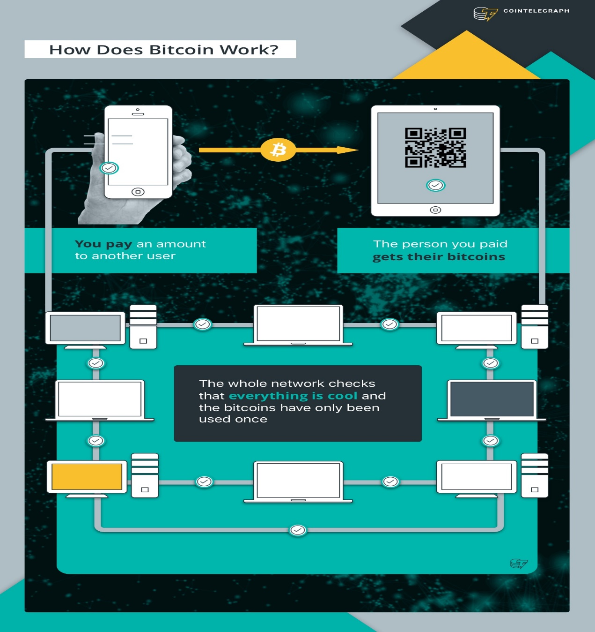
A user sees only number of Bitcoins on his or her wallet and transaction results. Behind the scenes, the Bitcoin network is sharing a public ledger called the "block chain". This ledger contains every transaction ever processed. Digital records of transactions are combined into "blocks". If someone try to change just one letter or number in a block of transactions, it will also affect all of the following blocks. Due to it being a public ledger, the mistake or fraud attempt can be easily spotted and corrected by anyone. User’s wallet can verify the validity of each transaction. The authenticity of each transaction is protected by digital signatures corresponding to the sending addresses. Because of the verification process and depending on the trading platform, it may take a few minutes for a BTC transaction to be completed. The Bitcoin protocol is designed so that each block takes about 10 minutes to mine.

2. Characteristics of Bitcoin:
- Decentralized:
One of Satoshi Nakamoto’s main objectives when creating Bitcoin was the network’s independence from any governing authorities. It is designed so that every person, business, as well as every machine involved in mining and transaction verification, becomes part of a vast network. Moreover, even if some part of the network goes down, the money will keep moving.
- Anonymous:
These days banks know virtually everything about their clients: credit history, addresses, phone numbers, spending habits and so on. It is all very different with Bitcoin, as the wallet doesn’t have to be linked to any personally identifying information. And while some people just simply don’t want their finances to be governed and tracked by any kind of an authority, others might argue that drug trade, terrorism and other illegal and dangerous activities will thrive in this relative anonymity.
- Transparent:
The anonymity of Bitcoin is only relative, as every single BTC transaction that ever happened is stored in the Blockchain. In theory, If your wallet address was publicly used, anyone can tell how much money is in it by carefully studying the blockchain ledger. However, tracing a particular Bitcoin address to a person is still nearly impossible. Those who wish to stay anonymous with their transactions can take measures to stay under the radar. There are certain types of wallets that prioritise opaqueness and security, but the simplest measure would be to use multiple addresses and not transfer massive amounts of money to a single wallet.
- Fast:
The Bitcoin network processes payments almost instantaneously, it normally takes just a few minutes for someone on the other side of the world to receive the money, while normal bank transfers can take several days.
- Non-repudiable:
Once you send your Bitcoins to someone, there is no way of getting them back, unless the recipient would want to send them back to you. This ensures the reception of a payment, meaning that whoever you’re trading with can’t scam you by claiming that they never got the money.

3. How Bitcoin Transactions Are Done?

All transactions are done in BLOCKCHAIN. (A blockchain is a growing list of records, called blocks, which are linked using cryptography.).A transaction is a transfer of value between Bitcoin wallets that gets included in the block chain.Bitcoin wallets keep a secret piece of data called a private key or seed, which is used to sign transactions, providing a mathematical proof that they have come from the owner of the wallet. The SIGNATURE also prevents the transaction from being altered by anybody once it has been issued.

4. What can I buy with Bitcoin?
Back in 2009, when Bitcoin was first introduced, it wasn’t very clear how and where you could spend it. Now, you can buy virtually everything. For example, giant companies like Microsoft and Dell accept payments in BTC for a variety of their products and digital content. You can fly with airlines such as AirBaltic and Air Lithuania, buy theatre tickets through UK’s Theatre Tickets Direct, get a few bottles of craft beer from Honest Brew, and so on.
Other options include paying for hotels and buying property, picking up bills in various bars and restaurants, joining a dating site, buying a gift card, placing a bet in an online-casino and donating for a good cause. There is also a flurry of diverse online marketplaces, trading in everything from illegal substances to high-end luxury items.
Bitcoin is a relatively new and quite complex form of payment, so it is only natural that the spending options are still limited, but every day more and more businesses - from small local coffee shops to industry giants - are accepting payments in BTC.
Moreover, due to its constantly fluctuating exchange rate, Bitcoin became a prime opportunity for investment. Despite still being an unstable and to some extent unrecognised currency, it became seven times more valuable over the last year, almost reaching a rate of $5000 for one BTC.

5. How to get Bitcoin?
The simplest way of getting Bitcoins is to buy them. Bitcoins are available from various exchanges, but you can also buy them directly from other people via marketplaces. They can be paid for with cash, credit and debit card transfers or even with other cryptocurrencies. But first, you’ll need a Bitcoin wallet.
There is a variety of options, but the main ones can be reduced to an online wallet and a software wallet on the hard drive of your computer. Neither option is completely safe, as a hard drive can become corrupted, while an online wallet might be prone to a hacker attack. There are also mobile wallets, which are very simplified due to an enormous storage capacity required to carry the entire Blockchain dedicated devices called hardware wallets and paper wallets with two QR-codes that are not stored digitally anywhere, making them immune to standard cyber-attacks and hardware failures.
And, of course, there’s mining. Just a few years ago, anyone with a powerful enough computer could mine Bitcoins, but this is not the case anymore. The BTC’s ever-increasing popularity as well as its exchange rate caused big companies to step into the game armed to the teeth with mining-specific devices, hence why the difficulty and energy required to mine worthwhile amounts of Bitcoins has skyrocketed. What’s more, the amount of Bitcoins still to be mined decreases constantly and drastically.

6. SYSTEM REQUIREMENTS :

6.1 Software Requirements:
Supported Operating System:
- Windows 7(32 or 64 bit), Windows 8(32 or 64 bit), Windows 10(32 or 64 bit)
- Linux (Ubuntu Linux)

Supported Development Environment:
- Python 2.7 or higher
- Pip modules( Jupyter Notebook, numpy, pandas, quandl, sklearn)

6.2 Hardware Requirements:
- Processor: 1.8 GHZ
- RAM: 4 GB
- ROM: 160 GB

7. TECHNOLOGY :
Bitcoin (₿) is a cryptocurrency, a form of electronic cash. It is a decentralized digital currency without a central bank or single administrator that can be sent from user-to-user on the peer-to-peer bitcoin network without the need for intermediaries.
Transactions are verified by network nodes through cryptography and recorded in a public distributed ledger. called a blockchain. Bitcoin was invented by an unknown person or group of people using the name Satoshi Nakamoto and released as open-software programs in 2009. Bitcoins are created as a reward for a process known as mining. They can be exchanged for other currencies, products, and services. Research produced by the University Of Cambridge estimates that in 2017, there were 2.9 to 5.8 million unique users using a cryptocurrency wallet, most of them using bitcoin.
Bitcoin has been criticized for its use in illegal transactions, its high electricity consumption, price volatility, thefts from exchanges, and the possibility that bitcoin is a Economic Bubble. Bitcoin has also been used as an investment, although several regulatory agencies have issued investor alerts about bitcoin.

7.1What is Python?
Python is an interpreted high-level programming language for general-purpose programming. Created by Guido van Rossum and first released in 1991, Python has a design philosophy that emphasizes code readability, notably using significant whitespace. It provides constructs that enable clear programming on both small and large scales. In July 2018, Van Rossum stepped down as the leader in the language community after 30 years.

Python features a dynamic type system and automatic memory management. It supports multiple programming paradigms, including object-oriented, imperative, functional and procedural, and has a large and comprehensive standard library.

Python interpreters are available for many operating systems. CPython, the reference implementation of Python, is open source software and has a community-based development model, as do nearly all of Python's other implementations. Python and CPython are managed by the non-profit Python Software Foundation.

7.1.1 Python Features :
Python is a multi-paradigm programming language. Object-oriented programming and structured programming are fully supported, and many of its features support functional programming and aspect-oriented programming (including by metaprogramming and metaobjects (magic methods)). Many other paradigms are supported via extensions, including design by contract and logic programming.

Python uses dynamic typing, and a combination of reference counting and a cycle-detecting garbage collector for memory management. It also features dynamic name resolution (late binding), which binds method and variable names during program execution.

Python's design offers some support for functional programming in the Lisp tradition. It has filter(), map(), and reduce() functions; list comprehensions, dictionaries, and sets; and generator expressions. The standard library has two modules (itertools and functools) that implement functional tools borrowed from Haskell and Standard ML.

The language's core philosophy is summarized in the document The Zen of Python (PEP 20), which includes aphorisms such as:

- Beautiful is better than ugly
- Explicit is better than implicit
- Simple is better than complex
- Complex is better than complicated
- Readability counts
Rather than having all of its functionality built into its core, Python was designed to be highly extensible. This compact modularity has made it particularly popular as a means of adding programmable interfaces to existing applications. Van Rossum's vision of a small core language with a large standard library and easily extensible interpreter stemmed from his frustrations with ABC, which espoused the opposite approach.

While offering choice in coding methodology, the Python philosophy rejects exuberant syntax (such as that of Perl) in favor of a simpler, less-cluttered grammar. As Alex Martelli put it: "To describe something as 'clever' is not considered a compliment in the Python culture." Python's philosophy rejects the Perl "there is more than one way to do it" approach to language design in favor of "there should be one—and preferably only one—obvious way to do it".

Python's developers strive to avoid premature optimization, and reject patches to non-critical parts of CPython that would offer marginal increases in speed at the cost of clarity. When speed is important, a Python programmer can move time-critical functions to extension modules written in languages such as C, or use PyPy, a just-in-time compiler. Cython is also available, which translates a Python script into C and makes direct C-level API calls into the Python interpreter.

An important goal of Python's developers is keeping it fun to use. This is reflected in the language's name—a tribute to the British comedy group Monty Python and in occasionally playful approaches to tutorials and reference materials, such as examples that refer to spam and eggs (from a famous Monty Python sketch) instead of the standard foo and bar.

A common neologism in the Python community is pythonic, which can have a wide range of meanings related to program style. To say that code is pythonic is to say that it uses Python idioms well, that it is natural or shows fluency in the language, that it conforms with Python's minimalist philosophy and emphasis on readability. In contrast, code that is difficult to understand or reads like a rough transcription from another programming language is called unpythonic.

Users and admirers of Python, especially those considered knowledgeable or experienced, are often referred to as Pythonists, Pythonistas, and Pythoneers.

7.1.2 Python Libraries:
Python's large standard library, commonly cited as one of its greatest strengths, provides tools suited to many tasks. For Internet-facing applications, many standard formats and protocols such as MIME and HTTP are supported. It includes modules for creating graphical user interfaces, connecting to relational databases, generating pseudorandom numbers, arithmetic with arbitrary precision decimals, manipulating regular expressions, and unit testing.

Some parts of the standard library are covered by specifications (for example, the Web Server Gateway Interface (WSGI) implementation wsgiref follows PEP 333), but most modules are not. They are specified by their code, internal documentation, and test suites (if supplied). However, because most of the standard library is cross-platform Python code, only a few modules need altering or rewriting for variant implementations.

As of March 2018, the Python Package Index (PyPI), the official repository for third-party Python software, contains over 130,000 packages with a wide range of functionality, including:

- Graphical user interfaces
- Web frameworks
- Multimedia
- Databases
- Networking
- Test frameworks
- Automation
- Web scraping
- Documentation
- System administration
- Scientific computing
- Text processing
- Image processing

7.1.3 Python Developing Environments:
Most Python implementations (including CPython) include a read–eval–print loop (REPL), permitting them to function as a command line interpreter for which the user enters statements sequentially and receives results immediately.

Other shells, including IDLE and IPython, add further abilities such as auto-completion, session state retention and syntax highlighting.

As well as standard desktop integrated development environments, there are Web browser-based IDEs; SageMath (intended for developing science and math-related Python programs); PythonAnywhere, a browser-based IDE and hosting environment; and Canopy IDE, a commercial Python IDE emphasizing scientific computing.

7.1.4 Python Implementations:
- Reference implementation:
CPython is the reference implementation of Python. It is written in C, meeting the C89 standard with several select C99 features. It compiles Python programs into an intermediate bytecode which is then executed by its virtual machine. CPython is distributed with a large standard library written in a mixture of C and native Python. It is available for many platforms, including Windows and most modern Unix-like systems. Platform portability was one of its earliest priorities.

- Other implementations
PyPy is a fast, compliant interpreter of Python 2.7 and 3.5. Its just-in-time compiler brings a significant speed improvement over CPython.

Stackless Python is a significant fork of CPython that implements microthreads; it does not use the C memory stack, thus allowing massively concurrent programs. PyPy also has a stackless version.

MicroPython and CircuitPython are Python 3 variants optimised for microcontrollers.

- Unsupported implementations
Other just-in-time Python compilers have been developed, but are now unsupported:

Google began a project named Unladen Swallow in 2009 with the aim of speeding up the Python interpreter fivefold by using the LLVM, and of improving its multithreading ability to scale to thousands of cores.
Psyco is a just-in-time specialising compiler that integrates with CPython and transforms bytecode to machine code at runtime. The emitted code is specialised for certain data types and is faster than standard Python code.
In 2005, Nokia released a Python interpreter for the Series 60 mobile phones named PyS60. It includes many of the modules from the CPython implementations and some additional modules to integrate with the Symbian operating system. The project has been kept up-to-date to run on all variants of the S60 platform, and several third-party modules are available. The Nokia N900 also supports Python with GTK widget libraries, enabling programs to be written and run on the target device.

- Cross-compilers to other languages
There are several compilers to high-level object languages, with either unrestricted Python, a restricted subset of Python, or a language similar to Python as the source language:

- Jython compiles into Java byte code, which can then be executed by every Java virtual machine implementation. This also enables the use of Java class library functions from the Python program.
- IronPython follows a similar approach in order to run Python programs on the .NET Common Language Runtime.
- The RPython language can be compiled to C, Java bytecode, or Common Intermediate Language, and is used to build the PyPy interpreter of Python.
- Pyjs compiles Python to JavaScript.
- Cython compiles Python to C and C++.
- Pythran compiles Python to C++.
- Somewhat dated Pyrex (latest release in 2010) and Shed Skin (latest release in 2013) compile to C and C++ respectively.
- Google's Grumpy compiles Python to Go.
- MyHDL compiles Python to VHDL.
- Nuitka compiles Python into C++.
- Performance
A performance comparison of various Python implementations on a non-numerical (combinatorial) workload was presented at EuroSciPy '13.

7.1.5 Python Development:
Python's development is conducted largely through the Python Enhancement Proposal (PEP) process, the primary mechanism for proposing major new features, collecting community input on issues and documenting Python design decisions.[110] Outstanding PEPs are reviewed and commented on by the Python community and Guido Van Rossum, Python's Benevolent Dictator For Life.[110]

Enhancement of the language corresponds with development of the CPython reference implementation. The mailing list python-dev is the primary forum for the language's development. Specific issues are discussed in the Roundup bug tracker maintained at python.org.[111] Development originally took place on a self-hosted source-code repository running Mercurial, until Python moved to GitHub in January 2017.[112]

CPython's public releases come in three types, distinguished by which part of the version number is incremented:

Backward-incompatible versions, where code is expected to break and need to be manually ported. The first part of the version number is incremented. These releases happen infrequently—for example, version 3.0 was released 8 years after 2.0.
Major or "feature" releases, about every 18 months, are largely compatible but introduce new features. The second part of the version number is incremented. Each major version is supported by bugfixes for several years after its release.[113]
Bugfix releases, which introduce no new features, occur about every 3 months and are made when a sufficient number of bugs have been fixed upstream since the last release. Security vulnerabilities are also patched in these releases. The third and final part of the version number is incremented.[114]
Many alpha, beta, and release-candidates are also released as previews and for testing before final releases. Although there is a rough schedule for each release, they are often delayed if the code is not ready. Python's development team monitors the state of the code by running the large unit test suite during development, and using the BuildBot continuous integration system.[115]

The community of Python developers has also contributed over 86,000[116] software modules (as of 20 August 2016) to the Python Package Index (PyPI), the official repository of third-party Python libraries.

The major academic conference on Python is PyCon. There are also special Python mentoring programmes, such as Pyladies.

7.2 What is Machine Learning?
Machine learning is an application of artificial intelligence (AI) that provides systems the ability to automatically learn and improve from experience without being explicitly programmed. Machine learning focuses on the development of computer programs that can access data and use it learn for themselves.
The process of learning begins with observations or data, such as examples, direct experience, or instruction, in order to look for patterns in data and make better decisions in the future based on the examples that we provide. The primary aim is to allow the computers learn automatically without human intervention or assistance and adjust actions accordingly.

Some machine learning methods
Machine learning algorithms are often categorized as supervised or unsupervised.
- Supervised machine learning algorithms can apply what has been learned in the past to new data using labeled examples to predict future events. Starting from the analysis of a known training dataset, the learning algorithm produces an inferred function to make predictions about the output values. The system is able to provide targets for any new input after sufficient training. The learning algorithm can also compare its output with the correct, intended output and find errors in order to modify the model accordingly.
- In contrast, unsupervised machine learning algorithms are used when the information used to train is neither classified nor labeled. Unsupervised learning studies how systems can infer a function to describe a hidden structure from unlabeled data. The system doesn’t figure out the right output, but it explores the data and can draw inferences from datasets to describe hidden structures from unlabeled data.
- Semi-supervised machine learning algorithms fall somewhere in between supervised and unsupervised learning, since they use both labeled and unlabeled data for training – typically a small amount of labeled data and a large amount of unlabeled data. The systems that use this method are able to considerably improve learning accuracy. Usually, semi-supervised learning is chosen when the acquired labeled data requires skilled and relevant resources in order to train it / learn from it. Otherwise, acquiringunlabeled data generally doesn’t require additional resources.
- Reinforcement machine learning algorithms is a learning method that interacts with its environment by producing actions and discovers errors or rewards. Trial and error search and delayed reward are the most relevant characteristics of reinforcement learning. This method allows machines and software agents to automatically determine the ideal behavior within a specific context in order to maximize its performance. Simple reward feedback is required for the agent to learn which action is best; this is known as the reinforcement signal.
Machine learning enables analysis of massive quantities of data. While it generally delivers faster, more accurate results in order to identify profitable opportunities or dangerous risks, it may also require additional time and resources to train it properly. Combining machine learning with AI and cognitive technologies can make it even more effective in processing large volumes of information.

7.2 Introduction to Machine Learning Algorithms: Linear Regression:
Artificial Intelligence has become prevalent recently. People across different disciplines are trying to apply AI to make their tasks a lot easier. For example, economists are using AI to predict future market prices to make a profit, doctors use AI to classify whether a tumor is malignant or benign, meteorologists use AI to predict the weather, HR recruiters use AI to check the resume of applicants to verify if the applicant meets the minimum criteria for the job, etc. The impetus behind such ubiquitous use of AI is machine learning algorithms. For anyone who wants to learn ML algorithms but hasn’t gotten their feet wet yet, you are at the right place. The rudimentary algorithm that every Machine Learning enthusiast starts with is a linear regression algorithm. Therefore, we shall do the same as it provides a base for us to build on and learn other ML algorithms.
7.2.1 What is Linear Regression?
Before knowing what is linear regression, let us get ourselves accustomed to regression. Regression is a method of modeling a target value based on independent predictors. This method is mostly used for forecasting and finding out cause and effect relationship between variables. Regression techniques mostly differ based on the number of independent variables and the type of relationship between the independent and dependent variables.
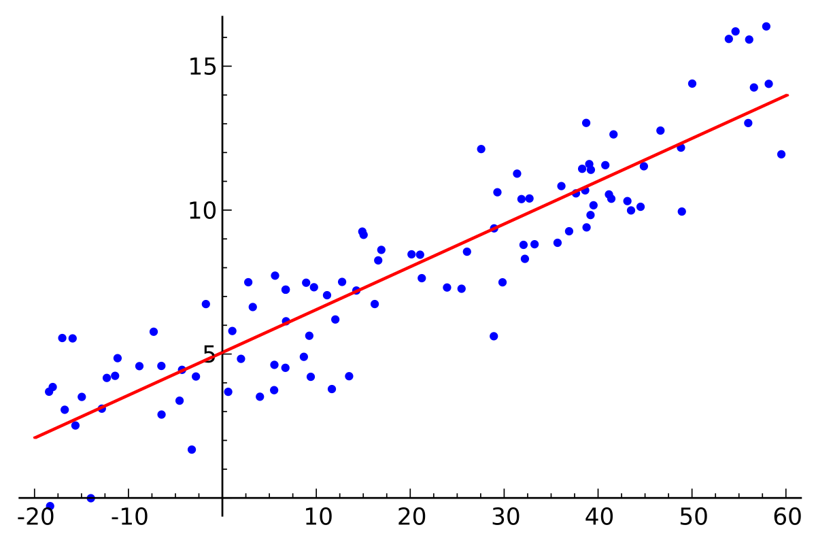
Simple linear regression is a type of regression analysis where the number of independent variables is one and there is a linear relationship between the independent(x) and dependent(y) variable. The red line in the above graph is referred to as the best fit straight line. Based on the given data points, we try to plot a line that models the points the best. The line can be modelled based on the linear equation shown below.

y = a_0 + a_1 * x ## Linear Equation

The motive of the linear regression algorithm is to find the best values for a_0 and a_1. Before moving on to the algorithm, let’s have a look at two important concepts you must know to better understand linear regression.

7.1.2 Cost Function:
The cost function helps us to figure out the best possible values for a_0 and a_1 which would provide the best fit line for the data points. Since we want the best values for a_0 and a_1, we convert this search problem into a minimization problem where we would like to minimize the error between the predicted value and the actual value.

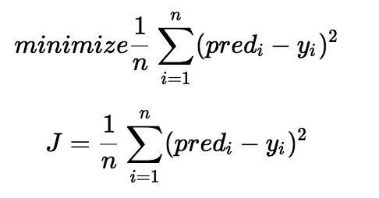

We choose the above function to minimize. The difference between the predicted values and ground truth measures the error difference. We square the error difference and sum over all data points and divide that value by the total number of data points. This provides the average squared error over all the data points. Therefore, this cost function is also known as the Mean Squared Error(MSE) function. Now, using this MSE function we are going to change the values of a_0 and a_1 such that the MSE value settles at the minima.

7.1.3 Gradient Descent:
The next important concept needed to understand linear regression is gradient descent. Gradient descent is a method of updating a_0 and a_1 to reduce the cost function(MSE). The idea is that we start with some values for a_0 and a_1 and then we change these values iteratively to reduce the cost. Gradient descent helps us on how to change the values.

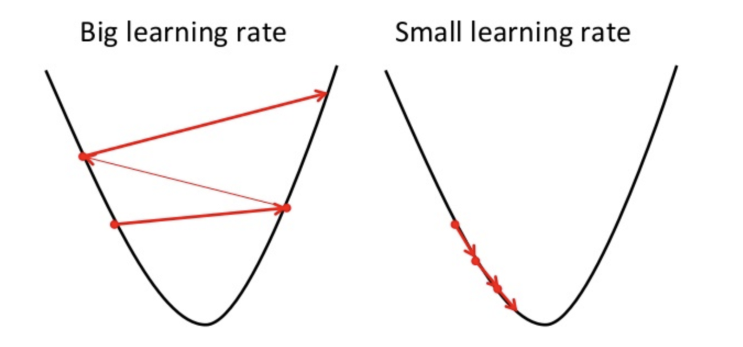
To draw an analogy, imagine a pit in the shape of U and you are standing at the topmost point in the pit and your objective is to reach the bottom of the pit. There is a catch, you can only take a discrete number of steps to reach the bottom. If you decide to take one step at a time you would eventually reach the bottom of the pit but this would take a longer time. If you choose to take longer steps each time, you would reach sooner but, there is a chance that you could overshoot the bottom of the pit and not exactly at the bottom. In the gradient descent algorithm, the number of steps you take is the learning rate. This decides on how fast the algorithm converges to the minima.
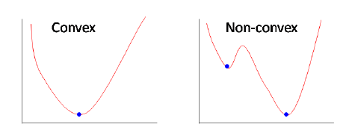
Sometimes the cost function can be a non-convex function where you could settle at a local minima but for linear regression, it is always a convex function.
You may be wondering how to use gradient descent to update a_0 and a_1. To update a_0 and a_1, we take gradients from the cost function. To find these gradients, we take partial derivatives with respect to a_0 and a_1. Now, to understand how the partial derivatives are found below you would require some calculus but if you don’t, it is alright. You can take it as it is.
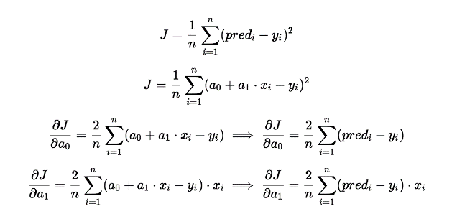
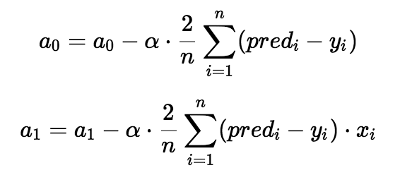

The partial derivates are the gradients and they are used to update the values of a_0 and a_1. Alpha is the learning rate which is a hyperparameter that you must specify. A smaller learning rate could get you closer to the minima but takes more time to reach the minima, a larger learning rate converges sooner but there is a chance that you could overshoot the minima.

8.QUANDL
Quandl is a platform used for business and economic purposes such as Share markets etc. This is used by economic professionals for studying the ups and downs of the stocks and utilities. In Python, Quandl is available as a predefined
package which can be imported and used for getting datasets for studying.

9.CODE:
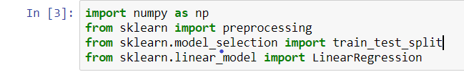

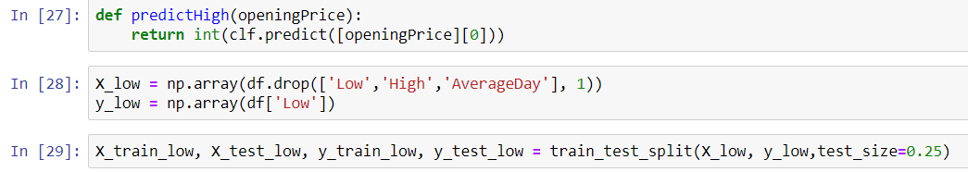

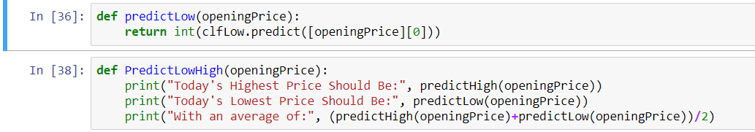

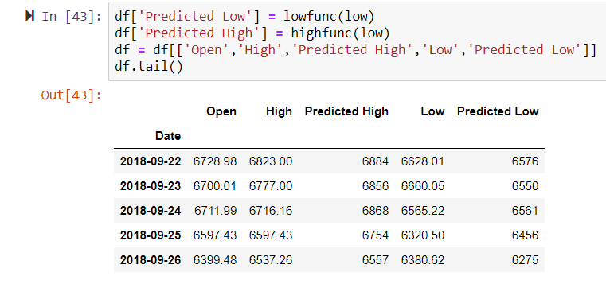

FINAL OUTPUT
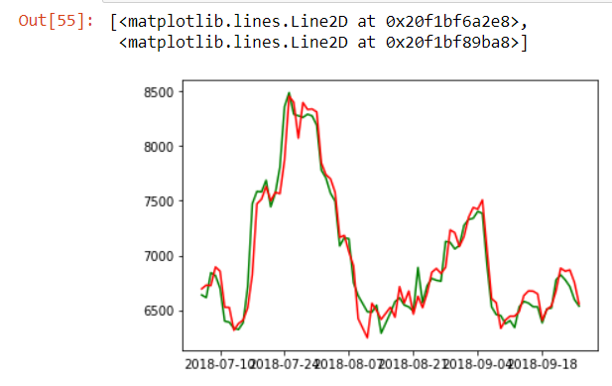
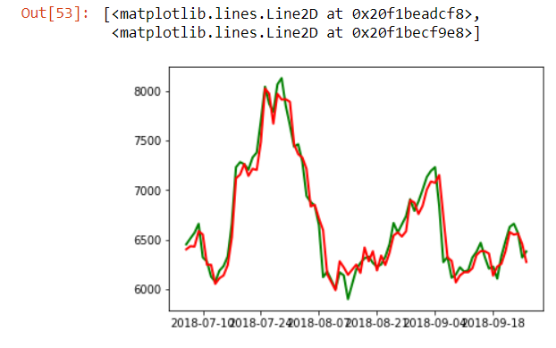

PREDICTED HIGH PREDICTED LOW
ORIGINAL VALUES-GREEN
PREDICTED VALUE-RED

CONCLUSION
Bitcoin is one of the most efficient cryptocurrency available in the world. Based on various factors bitcoin value is fluctuating in the world platform market. Using machine learning and linear regression, the value of bitcoin is predicted. This predicted values can be used to find out the future high and low values of the bitcoin and professionals and economists can ponder their solutions and strategies in this. The wide range of machine learning today can help people in various sectors like facial recognition, medical industry, automobile, economic sectors , iot etc. These advancements can be used for further development of the following sectors and can one’s work easy.

BIBLIOGRAPHY
- https://coinswitch.co/news/bitcoin-price-prediction-2018-btc-price-may-touch-15611-usd-in-2018-updated-11-06-2018

- https://medium.com/coinmonks/predicting-bitcoin-prices-using-linear-regression-and-gradient-descent-b1ec122ed5ee

- https://www.quandl.com/data/BITCOINWATCH-Bitcoin-Watch

- https://towardsdatascience.com/how-to-do-deep-learning-on-graphs-with-graph-convolutional-networks-7d2250723780

